The charter
*Project name : E-commerce(shoes)
*Project sponser : Dark store
*Title : assuit _alnemas street Egypt
*the phone : 043339256
*E-mail : darkstore@gmail.com
*Project manager :mr/Mohamed Salah
*The team:
عبدالله محمد عبدالسيد حسين
عبدالرحمن زكريا سنوسي خالد
*Purpose: As a result of the process of development in the Internet had to be marketing to get a share of the advantages of this so our project works on marketing (shoes) in an easy and fast way for users where they can buy and pay in several different ways to facilitate them
*Key deliverable:
1-web site
2-data base
3-buy chose
4-research
* general statement about how the team will approach the work:by using approach team will do this work
Basic timeline:3.5months
1.5month- initiation and gathering requirements
1month-for design and implement
20days-for system testing
10days for closing system and delivering
*Project resource :
Human:resource:stakeholders&darkstormanger &teams&sponser
Material:labs&internet
*Summery budget :200,000$
*Assumpetions :
1-every person can find us in internet
2-No one will leave the team
3-the payment will be in cash only
4- no showing product not exist in the company
*Constraint :
- 1-the budget will not be more than 200.000
- Do not show the profit rate attributed to the
- The information about customer is security

*Risks:
1-system break down
2- customer information steel
3-customer enter a wrong info
4-one of team leaves
5- financial viability
6- System Reliability

Project scope
1-Product Scope Description:
As a result of the process of development in the Internet had to be marketing to get a share of the advantages of this so our project works on marketing (shoes) in an easy and fast way for users where they can buy and pay in several different ways to facilitate them
How to use:
1- Browsing through website offered products:
Designed web pages that: show the products categories, page to show all products in any category and page to each product displays it information(picture, price, specifications…..etc). All these data will be saved in a specially designed database.
2- Search the website:
After the user enter keyword (company name, device model,….etc)to search for a specific product a query to the database executed to retrieve any information that matches the keyword.
3-Buy product and check-out:
User can add any product to his/her shopping cart. Added products number and total price will be displayed and updated as long as the user browse the site. When he checks out he’ll have to provide his address and credit card info. The database will be edited when this happens: products available quantities will change and this bought products will be added to that user purchases
Cost : 200.000$
2-Product Acceptance Criteria : the website
1-The service is available on any time.
2-create an website security system to protect
It from hacking and data theft.
3- The website is easy to use for those working on it
4- save a great time and effort.
5-High-End hardware/server equipments to ensure visitors have access to the website all the.
6 -All the designed web pages have the specific lines of codes that ensures comparability with each one of the specified browsers.
7 -All the components are designed and implemented with performance in mind to achieve the required minimum loading time.

3-Project Deliverables:
1-website
2-data base
3-buy chose
4-research
4-Project Exclusions:
- No mobile application
- On pay online

5-Project Constraints: are anything that limits the project manager’s options.
Project constraints include:
• Budgets: The project cost mustn’t exceed the range of
200.000$
• Deadline: The project must be done by the begin of the
next year
• Resources:
*The system hardware devices must all be from DELL
*The system software licenses must be accredited from
Oracle
*Servers must upload the database on the cloud
6-Project Assumptions
1-every person can find us in neternet
2-No one will leave the team
3-the payement will be in cash only
4- no showing product not exsit in the campny
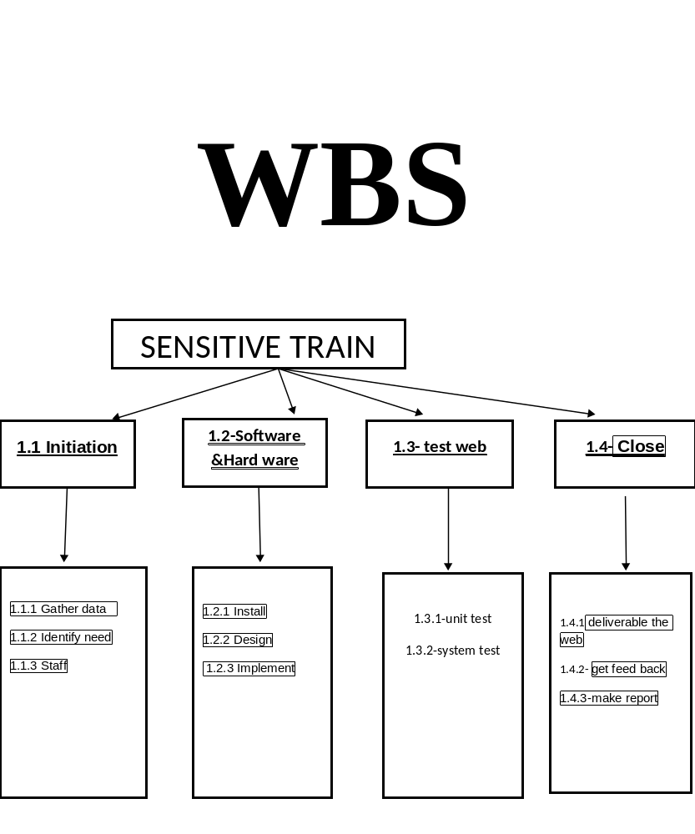
1. | Work package ID:
E-commerce for shoes | Work package name:
The work of the website to help the people and provide served for them | Description:
m.mohamed salah | Person:
1/1/2020 | Start date:
15/3/2020 | End date:

1.1 | Work package ID:
Initiation | Work package name:
The work to initiate the project. | Description:
m.mohamed salah&omar | Person:
1/1/2020 | Start date:
18/2/2020 | End date:

1.1.1 | Work package ID:
Gather data | Work package name:
Data is necessary for project management. It serves as the backbone for all types of decisions to be made by the project manager. It is, therefore, important to collect, organize and present data clearly so that all stakeholders will understand the status of the project. | Description:
Omar&sara | Person:
1/1/2020 | Start date:
14/1/2020 | End date:

1.1.2 | Work package ID:
Identify need | Work package name:
Identify sources, deliverables and targets through feasibility study | Description:
Omar&sara | Person:
15/1/2020 | Start date:
28/1/2020 | End date:

1.1.3 | Work package ID:
Staff | Work package name:
The planning process is officially started with a project kickoff meeting which includes the Project Manager, Project Team Project Sponsor ,experts, and stakeholders | Description:
M,Mohamed fouly&Ali | Person:
29/1/2020 | Start date:
11/2/2020 | End date:

1.2 | Work package ID:
Software& Hardware | Work package name:
The procurement of all hardware, software and facility needs for the project. | Description:
Doaa&sam&nour | Person:
18/2/2020 | Start date:
19/3/2020 | End date:

1.2.1 | Work package ID:
Install and development system | Work package name:
Team installs a development system for testing and customizations of user interfaces.  - buy pc  Install windows 10 -  install compiler for app and test | Description:
Sohila&nader | Person:
18/2/2020 | Start date:
25/2/2020 | End date:

1.2.2 | Work package ID:
Design system | Work package name:
The technical resources design the new widget management system. | Description:
Omar&sara | Person:
26/2/2020 | Start date:
12/3/2020 | End date:

1.2.3 | Work package ID:
Implement system | Work package name:
The actual system is installed and configured. | Description:
Sohib | Person:
12/3/2020 | Start date:
2/4/2020 | End date:

1.3 | Work package ID:
Web site testing | Work package name:
Test website for sure of its accuracy | Description:
Testers:ahmed&omar&sara | Person:
4/4/2020 | Start date:
17/4/2020 | End date:

1.3.1 | Work package ID:
Unit test | Work package name:
test each unit | Description:
Doaa | Person:
4/4/2020 | Start date:
24/4/2020 | End date:

1.3.2 | Work package ID:
System test | Work package name:
Test all system as aone component. | Description:
sohila | Person:
4/4/2020 | Start date:
17/4/2020 | End date:

1.4 | Work package ID:
Closing | Work package name:
Finishing all project let to end work to get earn. | Description:
Aml | Person:
17/4/2020 | Start date:
1/5/2020 | End date:

1.4.1 | Work package ID:
Deliverable the system | Work package name:
Time to deliver the finish system to customer. | Description:
m.mohamed fouly | Person:
17  /4/2020 | Start date:
23/4/2020 | End date:

1.4.2 | Work package ID:
Feed back | Work package name:
After deliver the system to customer we must collect reviews from them | Description:
ahmed | Person:
24/4/2020 | Start date:
29/4/2020 | End date:

1.4.3 | Work package ID:
Reporting | Work package name:
We must make an repor about all system for future use | Description:
hassna | Person:
30/3/2020 | Start date:
1/5/2020 | End date:

